
Mawlana Bhashani Science & Technology University

Lab Report No : 04
Course Code : ICT-3106
Course Title : Microprocessor and Assembly Language Lab

Submitted by Submitted to
Name : Maskur Al Shal Sabil S.M. Shamim
Id: IT18021 Lecturer
3rd year 1st semester Dept of ICT,
Session : 2017-2018 MBSTU
Dept of ICT
MBSTU

1. Write an assembly program to find larger number between two numbers.
;write an asembly program to find larger
;number between two number

.model small
.stack 100h
.data
n1 db '1st num: $'
n2 db 0dh,0ah,'2nd num: $'
max db 0dh,0ah,'max num: $'
.code
main proc
mov ax,@data
mov ds,ax

lea dx,n1
mov ah,9
int 21h

mov ah,1
int 21h

mov bl,al

lea dx,n2
mov ah,9
int 21h

mov ah,1
int 21h

mov cl,al
cmp bl,cl
jle next
jmp print
next:
mov bl,cl
jmp print

print:
lea dx,max
mov ah,9
int 21h

mov ah,2
mov dl,bl
int 21h

main endp
end main
Output:
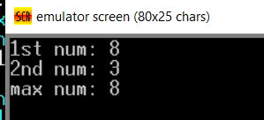

2. Write an assembly program to find small number between two numbers.
;write an asembly program to find larger
;number between two number

.model small
.stack 100h
.data
n1 db '1st num: $'
n2 db 0dh,0ah,'2nd num: $'
min db 0dh,0ah,'small num: $'
.code
main proc
mov ax,@data
mov ds,ax

lea dx,n1
mov ah,9
int 21h

mov ah,1
int 21h

mov bl,al

lea dx,n2
mov ah,9
int 21h

mov ah,1
int 21h

mov cl,al
cmp bl,cl
jg next
jmp print
next:
mov bl,cl
jmp print

print:
lea dx,min
mov ah,9
int 21h

mov ah,2
mov dl,bl
int 21h

main endp
end main
Output:
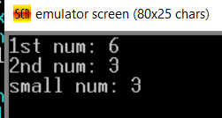

3. Write an assembly program to enter value of Al
If Al contains a negative number, put -1 In Bl;
if Al contains 0, put O In Bl;
if Al contains a positive number, put 1 In Bl.·

.model small
.stack 100h
.data
msg db 'enter a digit : $'

result db 0dh,0ah,'result : $'
negative db '-1$'

.code
main proc
mov ax,@data
mov ds,ax
lea dx,msg
mov ah,9
int 21h

mov ah,1
int 21h

cmp al,0
jg positive
jz zero
lea dx,negative
mov ah,9
int 21h

positive:
mov bl,1
jmp print

zero:
mov bl,0
jmp print

print:
mov ah,2
mov dl,0ah

int 21h

mov dl,0dh
int 21h

mov ah,2
mov dl,bl
add dl,30h
int 21h

main endp
end main
output:
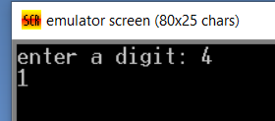

4. Write an assembly program to enter value of Al
If AL contains 1 or 3, display "o"; if AL contains 2 or 4, display "e".
.model small
.stack 100h
.code
main proc
mov ah,1
int 21h
mov bl,al
sub bl,30h

mov ah,2
mov dl,0ah
int 21h

mov ah,2
mov dl,0dh
int 21h

cmp bl,2
je even
cmp bl, 4
je even
cmp bl,1
je odd
cmp bl,3
je odd

jmp end
even:
mov ah,2
mov dl,'e'
int 21h

odd:
mov ah,2
mov dl,'o'
int 21h

end:

main endp
end main
output:
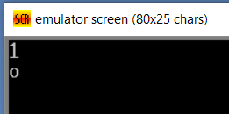

5. Write an assembly program to enter a character
if it's an uppercase letter, display it.
Otherwise terminate
.model small
.stack 100h
.code
main proc
mov ah,1
int 21h

mov bl,al

cmp bl,'a'
jge temp
jmp print
temp:
cmp bl,'z'
jle end
jmp print

print:
mov ah,2
mov dl,0ah
int 21h
mov dl,0dh
int 21h

mov ah,2
mov dl,bl
int 21h
end:

main endp
end main
output:
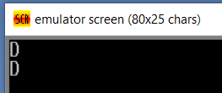

6. Write an assembly program to enter a character
if it's y or Y, display it.
Otherwise terminate
.model small
.stack 100h
.code
main proc
mov ah,1
int 21h

mov bl,al

cmp bl,'Y'
je print

cmp bl,'y'
je print

jmp end:
print:
mov ah,2
mov dl,bl
int 21h
end:

main endp
end main
output:
